36.21.12.1 Change EAN of partner

This is next step after 2.1.1 Customer Maintenance is done.

This function is used to correct the customer number in the first two fields if it is entered incorrectly in 36.21.1. Just do it.

Interface ID – a new customer number
Partner ID EDI - a new customer number
+ Next and that´s it

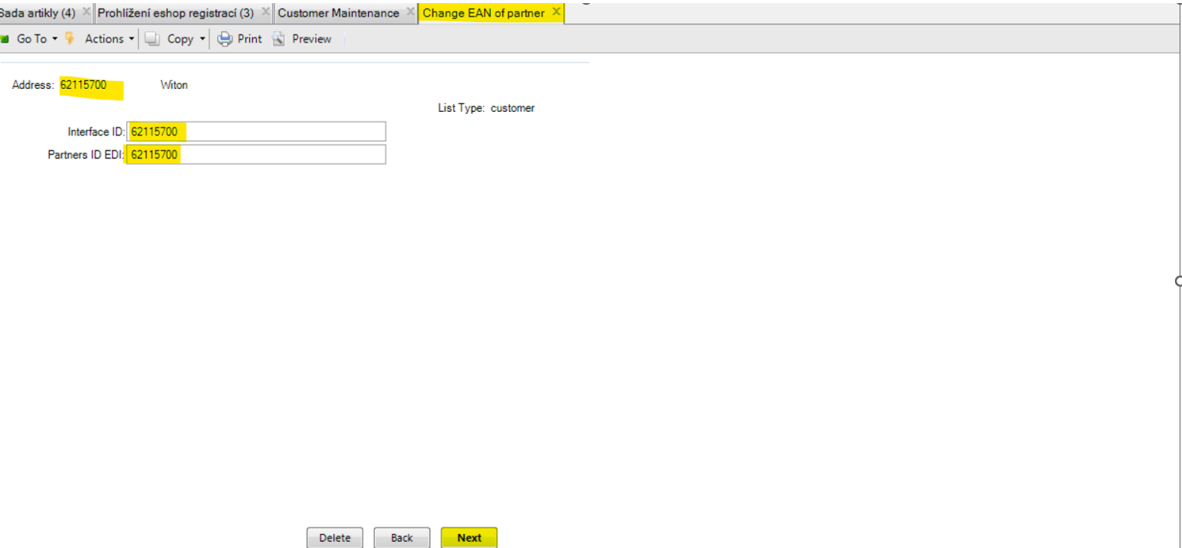

36.21.1 Parametrs of Partner – Maintenance

When 36.21.12.1 is done, now we have to set this function.

This function ensures that the correct template format is set for sending invoices via EDI to the invoicing center, i.e. to customers to their contacts in QAD CRM.

Address – a new customer number
Interface ID – a new customer number
Partners ID EDI – a new customer number
COPY FROM / Address – enter some already existing customer number from the same country (NL)
+ Next and that´s it

